Spam Filtering From Your ISP

March 2004

What’s Spam and Why Should I Filter It? 3
Friends Circle Gives You Control 3
Add newsletters and online shopping favorites 3
Setting the Spam Filter 4
Three Filtering Options 4
Spam Defense with Friends Circle 5
Friends Circle Only 6
Friends Circle with Confirmation 8
Subscribers Must Manage Mail with Confirmation 9
“Confirmation” Challenges E-mail Senders 9
The Challenge is easy (if you’re human) 9

What’s Spam and Why Should I Filter It?
If you’ve ever had an e-mail account, you know about unsolicited commercial e-mail, or Spam. Ads for Viagra, adult content, the latest diet craze and other marketing offers fill up your e-mail inbox and make it difficult to find messages from family and friends.
Your Internet service provider understands that you have e-mail in order to keep close with those in your circle—and not to receive a flood of Spam!
That’s why we’ve given you power over your e-mail inbox with three Spam filtering options.

Friends Circle Gives You Control
To give you the power to reject Spam, your ISP has given you control of your e-mail inbox with the Friends Circle. With the Friends Circle, you specify the addresses from which you will or will not accept e-mail.
With this powerful solution, you can specify to receive or reject e-mail from an individual address or an entire domain (see table below).
E-mail Type | Examples
Individual address | jdoe@trueband.net; epresley@yourdomain.coop
Entire domain | @aol.com; @earthlink.net

Add newsletters and online shopping favorites
If you subscribe to electronic newsletters or shop online, include those domain addresses in your Friends Circle.

Setting the Spam Filter
Login to the AdminTool using your user name and password.
Select Spam Filtering from the menu on the left (Figure 1).
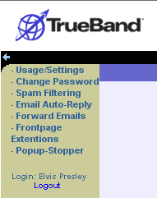
Figure 1

Three Filtering Options
At the Spam Filtering screen, select the level of Spam filtering that you would like from the dropdown menu (Figure 2). Descriptions of each level follow the dropdown menu.
After selecting the Spam filtering type, click the Next arrow to access the next screen. The screen that appears next will depend on the type of Spam filtering selected.
The remainder of this section of the manual will describe and illustrate each Spam filtering level.
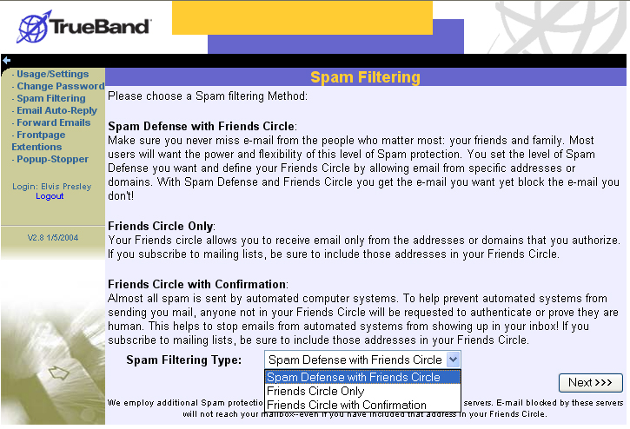
Figure 2

Spam Defense with Friends Circle
This is the default option. Never miss e-mail from the people who matter most: your friends and family. Most users will want the power and flexibility of this level of Spam protection. With Spam Defense and Friends Circle you get the e-mail you want yet block the e-mail you don't!

Select
To set, select Spam Defense with Friends Circle from the dropdown menu on the Spam Filtering screen (Figure 2).
Click the Next arrow to access the Spam Filtering – Spam Defense with Friends Circle screen (Figure 3).
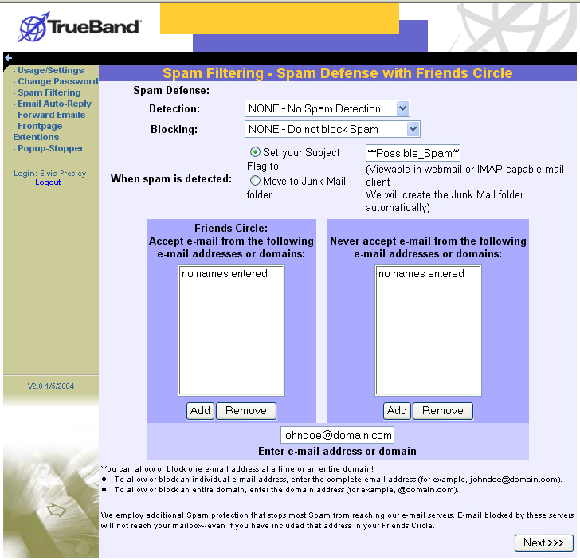
Figure 3
Set the level of Spam Detection and Blocking from their respective dropdown menus (see table below).
Spam Detection Levels | Spam Blocking Levels
High—99.94% Spam detected | Block ALL mail flagged as Spam
Medium—90% Spam detected | Block most Spam
Low—80% Spam detected | NONE—Do not block Spam
NONE—No Spam detected

Define
Next, define how Spam is managed via flagging and folder options.
Then, define your Friends Circle by entering those individual addresses or domains from which to accept e-mail as well as those from which to refuse e-mail.

Accept
Click the Next arrow to access the Change Settings – Verify screen (Figure 4).
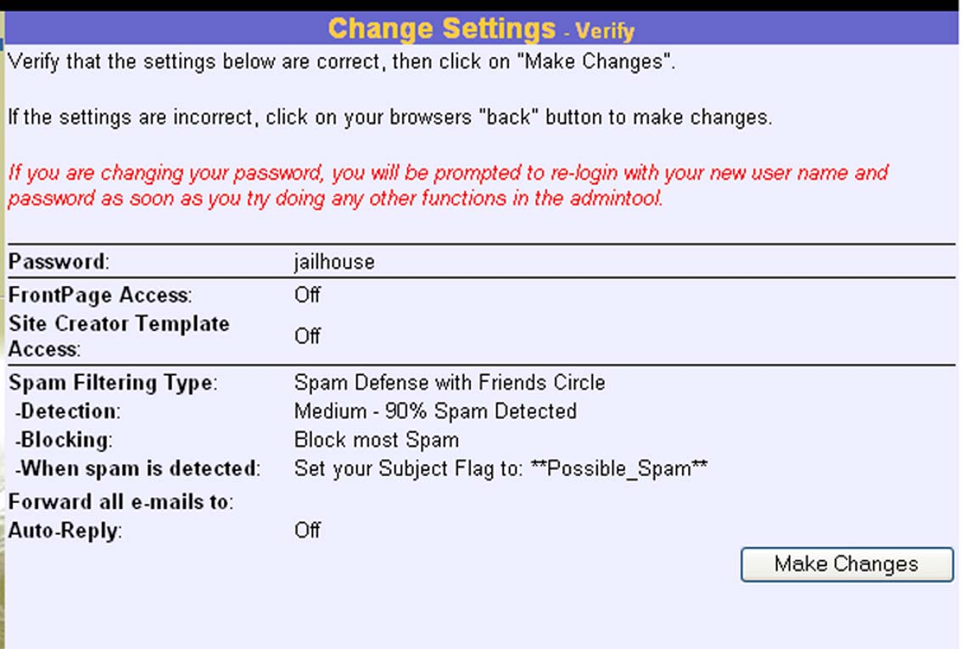
Figure 4
To accept the changes to the account, select the Make Changes button.

Friends Circle Only
With this setting, users receive e-mail only from the addresses or domains included in the Friends Circle.

Select
To set, select Friends Circle Only from the dropdown menu on the Spam Filtering screen (Figure 2).
Click the Next arrow to access the Spam Filtering – Friends Circle Only screen (Figure 5).
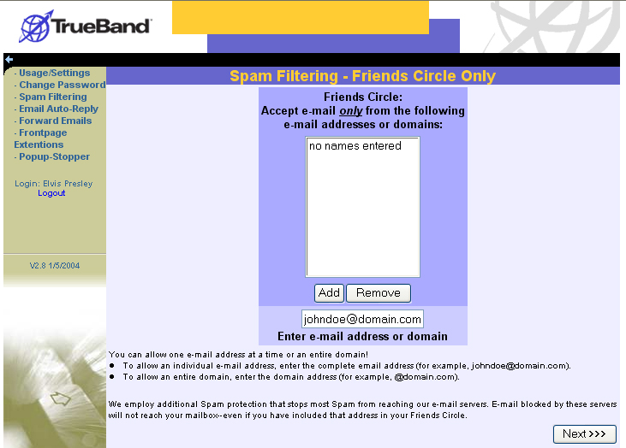
Figure 5

Define
Define your Friends Circle by entering individual addresses or entire domains.
If the user subscribes to electronic newsletters or receives computer-generated e-mail from online shopping sites, the user should include those domains (such as “@amazon.com” or “@ebay.com”) in the Friends Circle.

Accept
Click the Next arrow to access the Change Settings – Verify screen (Figure 6).
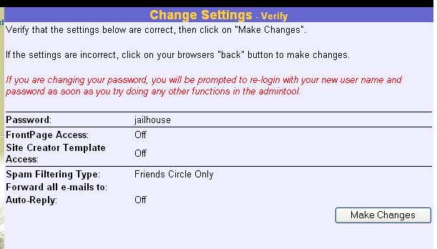
Figure 6
To accept the changes to the account, select the Make Changes button.

Friends Circle with Confirmation
Almost all Spam is sent by automated computer systems. To prevent automated systems from sending you mail, any address not in your Friends Circle will be requested to authenticate or prove they are human. This helps to stop emails from automated systems from showing up in your inbox!

Select
To set, select Friends Circle Only from the dropdown menu on the Spam Filtering screen (Figure 2).
Click the Next arrow to access the Spam Filtering – Friends Circle with Confirmation screen (Figure 7).
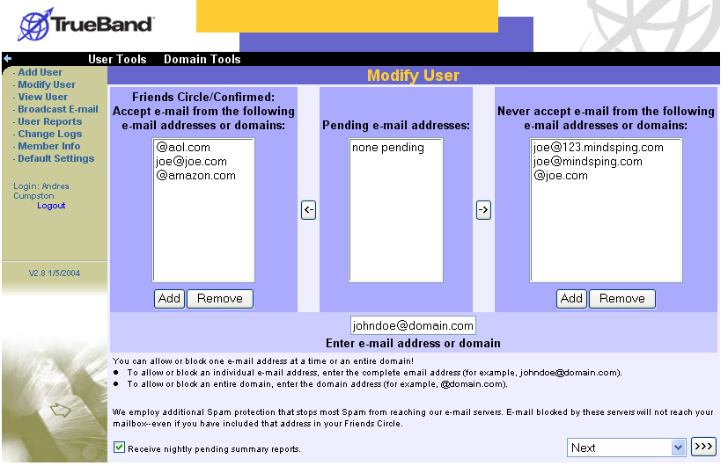
Figure 7

Define
Enter e-mail addresses to be included in the Friends Circle as well as those that are to be blocked. Users may enter individual addresses or entire domains.
If the user subscribes to electronic newsletters or receives computer-generated e-mail from online shopping sites, the user should include those domains (such as “@amazon.com” or “@ebay.com”) in the Friends Circle.

Accept
Click the Next arrow to access the Change Settings – Verify screen (Figure 6).
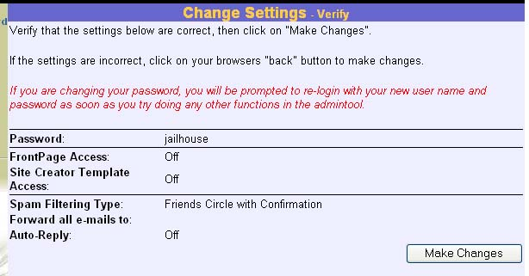
Figure 8
To accept the changes to the account, select the Make Changes button.

Subscribers Must Manage Mail with Confirmation
If you select Friends Circle with Confirmation, you will need to manage your mail in order to ensure that you receive all of the mail you want.
To get all of your mail, we recommend that you “two-step your way to less Spam” by:
- Creating a Friends Circle that includes
  - Friends and family with whom the user corresponds
  - Electronic newsletters
  - Domains for sites like e-Bay or favorite shopping sites
- Checking the AdminTool for “Pending” addresses
  - “Pending” addresses are those that have not responded to the challenge. If the challenge has not been taken within one week, the address will be blocked.
- Subscribers will be able to add pending addresses to the Friends Circle or the Block List at any time by logging into the AdminTool.

“Confirmation” Challenges E-mail Senders
When users set Friends Circle with Confirmation as the Spam filtering level, any sender of e-mail will be asked to take a “challenge.” Unless the sender takes and passes the challenge, the user will not receive e-mail from that sender.

The Challenge is easy (if you’re human)
When e-mail is sent to an account that has Friends Circle with Confirmation set, the sender receives the following message:
Hello,
In order for me to receive the e-mail that you recently sent, please click on the link below and follow the simple instructions provided. By doing so, you will be added to my list of approved senders and will be able to send messages without any further intervention.
Please take this action within a week of receiving this email. If no action is taken, I will not receive your message. Your help allows me to filter out my unwanted email!
[Link removed]
Thank you,
[User name]
Upon clicking the link included in the e-mail, the sender sees the following screen and must select the correct animal that is represented in the pictures (Figure 9).
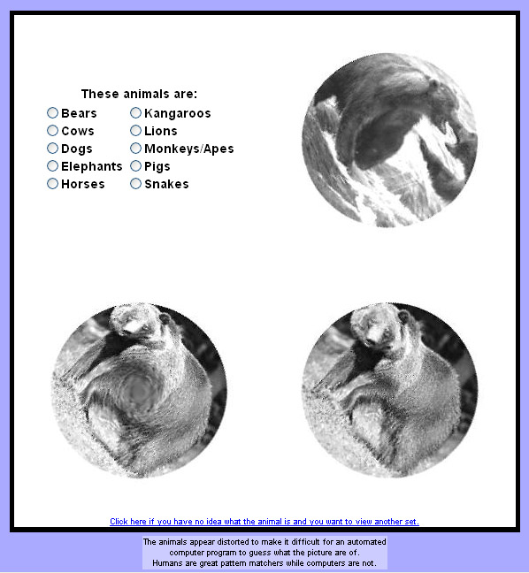
Figure 9
The images (in this illustration, of bears) appear distorted in order to make it difficult for an automated computer program to guess the animal represented.
If the correct image is chosen, the sender receives the following message (Figure 10):
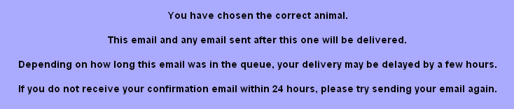
Figure 10
In addition, the sender receives e-mail containing the following message:
Hello,
Your confirmation was accepted, and so your pending message/s have been delivered.
Thanks for your cooperation.

